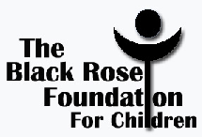

The James V. Brooks Memorial Music Scholarship Fund

Scholarship | Requirements | Deadline | #Recipients  Award Amount | Contacts
The James V. Brooks  Memorial Music Scholarship | - Duval County High School  - Band or chorus graduate  - Minimum 2.5 cumulative GPA for grades 9-12  - ACT or SAT Scores  - Enrolled as full time college student in degree seeking program  - Proof of 8 hours community service in Duval County area  - 300-500 word essay entitled: “A Kinder, Gentler Society…My Recipe”  - Read Essay with conviction at event | April 15th | Varies  $500 | Your School Guidance Office  Ms. Shirley Bing-(904) 502-9594  Dr. Sheila Flemming-Hunter  The Black Rose Foundation for Children  www.blackrosefoundation.org  (888) 530-9401

P.O. Box 311620 Atlanta, GA 31131 president@blackrosefoundation.org

